YEAR 2 HOME LEARNING
Week commencing 6th July
SPIRIT ALIVE
We hope you have all been enjoying taking part in the Spirit Alive activities for Brazil in your home learning packs and on our class pages. Don’t forget to enter these competitions:
- Make a hat to represent your country
- Draw and colour the national animal of your country
- Decorate a cake to show something about your country

You can send your entries to learning@beechwoodprimaryschool.co.uk . The winners will all receive prizes!

KEY WEBSITES
https://www.storynory.com/
Story Nory is a website that allows children to listen to different audiobooks read to them by the author. It also allows you to download the stories to keep for another time. These stories are suitable for kids of all ages.

https://www.bbc.co.uk/bitesize/tags/z7s22sg/year-2-lessons/1
BBC Bitesize - excellent range of daily lessons on lots of different subjects for your child to enjoy. New lessons are uploaded every day and include videos, practice activities, games and quizzes to help your child learn. You can watch programmes daily on BBC iPlayer (Bitesize Content)

MATHS
Please click on the link below and follow these lessons. There is one for each day with a video explaining the mathematical concept. Please complete the activities on a piece of paper or print off the sheet. If possible, send a photo of your home learning via the learning email. We would love to see all the hard work you are doing.
https://whiterosemaths.com/homelearning/year-2/
Please use the ‘Summer Term – Week 11’ set of lessons. The sheets to go with each lesson are under Parents ›› Home Learning Support ›› Mathematics ›› and ›› White Rose Maths Sheets on the school website.
ARITHMETIC
Don’t forget to keep practising multiplication and division tables and number bonds to 10 and 20. Do you know every answer to X2, X5 and X10 in and out of order really quickly? Get someone to test you to see how well you do.
Keep practising counting in threes and learning the 3 times table as well.

Use these websites to help you practise your times tables:

https://mathsframe.co.uk/en/resources/category/7/multiplication_and_division

http://www.maths-games.org/times-tables-games.html

https://www.topmarks.co.uk/maths-games/5-7-years/times-tables

SPELLINGS
The spellings to learn for this week are: common exception words
past
Spellings for Mrs White’s phonics group:

door
floor
poor
fast
last
past
class
prove
who
even
clothes
many
grass
whole

Please get someone to test you at the end of the week. Keep a record of your scores!

READING
Please keep reading at home! It is very important that you try and read at least 3 x per week. We’d love you to send us a photo of you reading if you haven’t already or a book review (template can be download from the parents, home learning support, reading tab of the school website). You can send them to the email: learning@beechwoodprimaryschool.co.uk .

Remember to look at the Reading’ section under Parents ›› Home Learning Support for links to websites where you can access free e-books, phonics and comprehension activities.

PSHE


This week we would like you to write about your time in year 2 and how you feel about going into year 3. What were your favourite parts about being in year 2? What did you enjoy doing? Which trips and activities did you like the most?

How do you feel about going into year 3? What is different about Key Stage 2 compared to Key Stage 1? What are you looking forward to? Is there anything you have any worries about?

You could write this down as a diary entry, make a scrapbook of your favourite memories or just down on paper. Have a go at drawing some pictures to go with your writing! Despite the current situation we have had some wonderful experiences teaching you in year 2 and would love to hear about yours.

We would love to see what you are looking forward to and any worries you may have. Please send your work to the learning email: learning@beechwoodprimaryschool.co.uk
PE

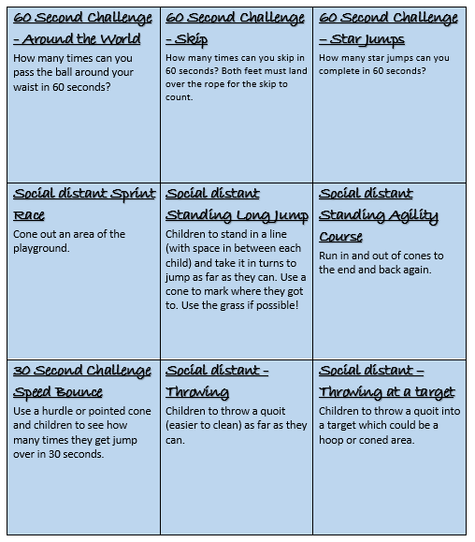

Please look after yourselves and your family and we hope to see you all again very soon.

Miss Westfield and Miss De Biasio

