YEAR 2 HOME LEARNING
Week commencing 22th June
Thank you to everyone who has sent us photos of their work or emailed us letters to: learning@beechwoodprimaryschool.co.uk We are really impressed with how hard you are all working at home and we love seeing what you are doing.
Don’t forget to look at what everyone else is doing: www.beechwoodprimaryschool.co.uk/what-weve-been-doing-at-home

EXCITING NEWS!
Even though we are not all at school, some of Year 6 have been busy thinking about how we can still do Spirit Alive this year. Next week’s work pack will include information about how you can get involved with the fun while you are at home.

KEY WEBSITES
https://www.freechildrenstories.com/
The free children stories website is a website that allows children to choose a story they would like to read and have it read to them by the author. It includes lovely pictures from the story and is suitable for kids of all ages.

https://www.bbc.co.uk/bitesize/tags/z7s22sg/year-2-lessons/1
BBC Bitesize - excellent range of daily lessons on lots of different subjects for your child to enjoy. New lessons are uploaded every day and include videos, practice activities, games and quizzes to help your child learn. You can watch programmes daily on BBC iPlayer (Bitesize Content)

MATHS
Please click on the link below and follow these lessons. There is one for each day with a video explaining the mathematical concept. Please complete the activities on a piece of paper or print off the sheet. If possible, send a photo of your home learning via the learning email. We would love to see all the hard work you are doing.
https://whiterosemaths.com/homelearning/year-2/
Please use the ‘Summer Term – Week 9’ set of lessons. The sheets to go with each lesson are under Parents ›› Home Learning Support ›› Mathematics ›› and ›› White Rose Maths Sheets on the school website.
ARITHMETIC
Don’t forget to keep practising multiplication and division tables and number bonds to 10 and 20. Do you know every answer to X2, X5 and X10 in and out of order really quickly? Get someone to test you to see how well you do.
Keep practising counting in threes and learning the 3 times table as well.

Free multiplication games to help you learn your times tables: https://www.timestables.co.uk/games/

SPELLINGS
The spellings to learn for this week are: common exception words
most
Spellings for Mrs White’s phonics group:

chair
fair
hair
loud
cloud
proud
only
both
old
cold
gold
told
great
break

Please get someone to test you at the end of the week. Keep a record of your scores!

Please take a look at the ‘Spelling Strategies’ sheet on our class pages to give you some different ideas of how you can practise your spellings. You also have a copy of this in your home learning pack from last week.

READING
Please keep reading at home! It is very important that you try and read at least 3 x per week. We’d love you to send us a photo of you reading if you haven’t already or a book review (template can be download from the parents, home learning support, reading tab of the school website). You can send them to the email: learning@beechwoodprimaryschool.co.uk .

Remember to look at the Reading’ section under Parents ›› Home Learning Support for links to websites where you can access free e-books, phonics and comprehension activities.

FOOD CHAINS
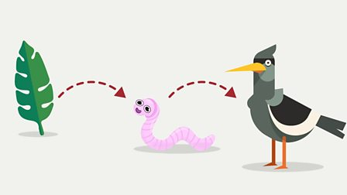

This week we would like you to research about food chains.

Can you find out what a food chain is? What different plants do animals eat? Do they eat other animals? Can you find or create a food chain that includes humans?
https://www.bbc.co.uk/bitesize/topics/zx882hv/articles/z3c2xnb
This BBC bitesize page has lots of information on food chains and a fun quiz for you to complete after. You could also use the child friendly search engine ‘Kiddle’ to carry out some of your own research instead.

You could draw and label some different food chains using a ruler and pencil. Can you use arrows to show the correct direction of the food chain? You might want to challenge yourself to try find the longest food chain that you can.

We would love to see what you have found out and what you have done. Please send them to the learning email: learning@beechwoodprimaryschool.co.uk

PE
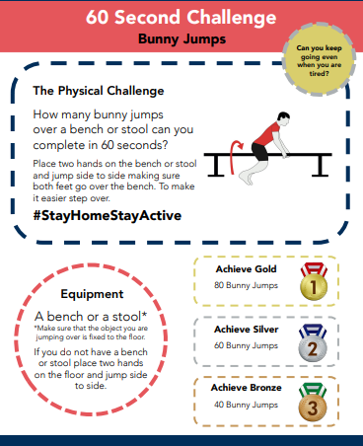
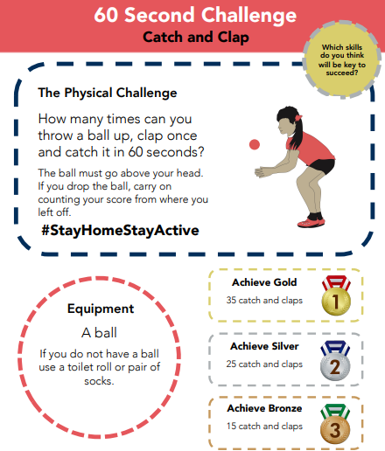

Please look after yourselves and your family and we hope to see you all again very soon.

Miss Westfield and Miss De Biasio

