YEAR 2 HOME LEARNING
Week commencing 15th June
Thank you to everyone who has sent us photos of their work or emailed us letters to: learning@beechwoodprimaryschool.co.uk We are really impressed with how hard you are all working at home and we love seeing what you are doing.
Don’t forget to look at what everyone else is doing: www.beechwoodprimaryschool.co.uk/what-weve-been-doing-at-home

KEY WEBSITES
https://www.worldbookday.com/storytime-online/
The World Book Day website are offering ‘Storytime Online’. Watch a wonderful range of famous authors and stars reading children’s books and short stories for kids of all ages.

https://www.bbc.co.uk/bitesize/tags/z7s22sg/year-2-lessons/1
BBC Bitesize - excellent range of daily lessons on lots of different subjects for your child to enjoy. New lessons are uploaded every day and include videos, practice activities, games and quizzes to help your child learn. You can watch programmes daily on BBC iPlayer (Bitesize Content)

MATHS
Please click on the link below and follow these lessons. There is one for each day with a video explaining the mathematical concept. Please complete the activities on a piece of paper or print off the sheet. If possible, send a photo of your home learning via the learning email. We would love to see all the hard work you are doing.
https://whiterosemaths.com/homelearning/year-2/
Please use the ‘Summer Term – Week 8’ set of lessons. The sheets to go with each lesson are under Parents ›› Home Learning Support ›› Mathematics ›› and ›› White Rose Maths Sheets on the school website.

ARITHMETIC
Don’t forget to keep practising multiplication and division tables and number bonds to 10 and 20. Do you know every answer to X2, X5 and X10 in and out of order really quickly? Get someone to test you to see how well you do.
Keep practising counting in threes and learning the 3 times table as well.

https://home.oxfordowl.co.uk/kids-activities/fun-maths-games-and-activities/
Oxford Owls has a great range of online mental maths games, worksheets and videos to help you with methods on their website.
https://www.topmarks.co.uk/maths-games/5-7-years/counting
Top Marks has lots of different games to help you practise.

SPELLINGS
The spellings to learn for this week are: the ‘sh’ sound spelt ‘s’
television
Spellings for Mrs White’s phonics group:

door
poor
floor
find
kind
mind
treasure
usual

Extra spellings:

beautiful
pretty
child
children
everybody

Please get someone to test you at the end of the week. Keep a record of your scores!

Spell Zone – follow the link below for activities, games and writing sheets to use for the spelling pattern you are learning this week:
https://www.spellzone.com/word_lists/list-4613.htm

READING
Please keep reading at home! It is very important that you try and read at least 3 x per week. We’d love you to send us a photo of you reading if you haven’t already or a book review (template can be download from the parents, home learning support, reading tab of the school website). You can send them to the email: learning@beechwoodprimaryschool.co.uk .

Remember to look at the Reading’ section under Parents ›› Home Learning Support for links to websites where you can access free e-books, phonics and comprehension activities.

BEACH HABITATS

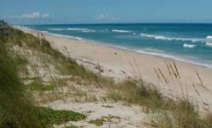

This week we would like you to research beach habitats. We have put some information in your new home learning packs and an activity for you to complete.

Can you find out what it is like in a beach habitat and which animals and plants live there?
https://www.bbc.co.uk/bitesize/topics/zx882hv/articles/zy38wmn or you could use the child friendly search engine ‘Kiddle’ to carry out some research.

You could create a poster or draw the habitat and label the animals and plants that live there. Can you talk about the different places like the seaside town, rock pools, beach, sand dunes, cliffs and sea/ocean and what lives there?

We would love to see what you have found out and what you have done. Please send them to the learning email: learning@beechwoodprimaryschool.co.uk

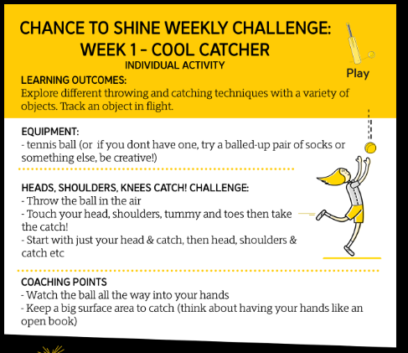
PE

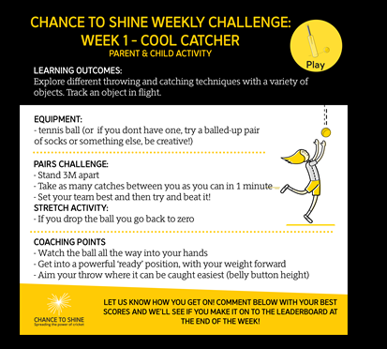

Please look after yourselves and your family and we hope to see you all again very soon.

Miss Westfield and Miss De Biasio

