YEAR 2 HOME LEARNING
Week commencing 8th June
Thank you to everyone who has sent us photos of their work or emailed us letters to: learning@beechwoodprimaryschool.co.uk We are really impressed with how hard you are all working at home and we love seeing what you are doing.
Don’t forget to look at what everyone else is doing: www.beechwoodprimaryschool.co.uk/what-weve-been-doing-at-home

KEY WEBSITES
https://usborne.com/play-and-learn-at-home/virtual-days-out/virtual-days-out/
Usborne Virtual Tours - Would you like to visit a castle, go on a day trip to London or see dinosaurs in a museum? Well, don’t let the current situation stop you! With their activity sheets and links to websites with video tours and activities, you can have a virtual trip! Choose a trip from the list and check back regularly for more days out.

https://www.bbc.co.uk/bitesize/tags/z7s22sg/year-2-lessons/1
BBC Bitesize - excellent range of daily lessons on lots of different subjects for your child to enjoy. New lessons are uploaded every day and include videos, practice activities, games and quizzes to help your child learn. You can watch programmes daily on BBC iPlayer (Bitesize Content)

MATHS
Please click on the link below and follow these lessons. There is one for each day with a video explaining the mathematical concept. Please complete the activities on a piece of paper or print off the sheet. If possible, send a photo of your home learning via the learning email. We would love to see all the hard work you are doing.
https://whiterosemaths.com/homelearning/year-2/
Please use the ‘Summer Term – Week 7’ set of lessons. The sheets to go with each lesson are under Parents ›› Home Learning Support ›› Mathematics ›› and ›› White Rose Maths Sheets on the school website.

ARITHMETIC
Don’t forget to keep practising multiplication and division tables and number bonds to 10 and 20. Do you know every answer to X2, X5 and X10 in and out of order really quickly? Get someone to test you to see how well you do.
Keep practising counting in threes and learning the 3 times table as well.

https://home.oxfordowl.co.uk/kids-activities/fun-maths-games-and-activities/
Oxford Owls has a great range of online mental maths games, worksheets and videos to help you with methods on their website.
https://www.topmarks.co.uk/maths-games/5-7-years/counting
Top Marks has lots of different games to help you practise.

SPELLINGS
The spellings to learn for this week are: the ‘u’ sound spelt ‘o’
other
Spellings for Mrs White’s phonics group: the ‘r’ sound at the beginning of a word spelt ‘wr’

wrong
write
wrote
wrap
written
mother
brother
nothing
Monday
another
money
honey
month
cover

Please get someone to test you at the end of the week. Keep a record of your scores!

Spell Zone – follow the link below for activities, games and writing sheets to use for the spelling pattern you are learning this week:
https://www.spellzone.com/word_lists/list-179.htm

READING
Please keep reading at home! It is very important that you try and read at least 3 x per week. We’d love you to send us a photo of you reading if you haven’t already or a book review (template can be download from the parents, home learning support, reading tab of the school website). You can send them to the email: learning@beechwoodprimaryschool.co.uk .

Remember to look at the Reading’ section under Parents ›› Home Learning Support for links to websites where you can access free e-books, phonics and comprehension activities.

SEASIDES TOPIC
This week we would like you to write a setting description for this picture:
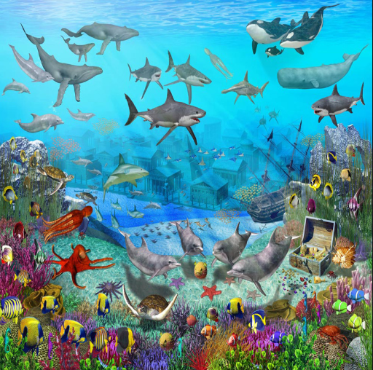

First of all, think about what you would be able to see, hear and feel.
Describe what you can see in as much detail as possible.
You need to remember to use capital letters and full stops correctly.

In your setting description, make sure you include expanded noun phrases and a range of conjunctions.
Miss Westfield has made some videos on the school website to help you to remember how to use them. Go to Children ›› Grammar Demonstration Videos.
Try and use different sentences starters to make your writing more interesting. Here are some you might like to use:
On the sea bed… Behind me…
Up above… Inside the ancient chest…
We would love to see what you have found out and what you have done. We would love to see them so please send them to the learning email: learning@beechwoodprimaryschool.co.uk
PE
Shake up games inspired by Disney and Pixar’s Toy Story 4 and Incredibles 2 and Disney’s The Lion King and Frozen. These are 10 minute bursts of fun that will get you moving!
https://www.nhs.uk/10-minute-shake-up/shake-ups

School Games Organisers are supporting the national effort to ensure young people and their families have access to fun ways of staying active. Over the next 26 working days the CSW SGO’s will be bringing you challenges linked to the School Games.
http://www.thinkactive.org/wethinkactive/kids-active-learning/a-z-challenge/

Please look after yourselves and your family and we hope to see you all again very soon.

Miss Westfield and Miss De Biasio

