WALT: use commas to separate items in lists.
Use the ‘Commas in Lists’ PowerPoint on our class page to learn how to use commas.
Try and complete these activities to show your understanding of commas in lists. Green is easier, amber is medium difficulty and red is more challenging. Pick the one you think you can do but remember to challenge yourself! Can you complete all three?
Complete the sentences by putting the items in a list using commas and ‘and’.
Amy’s favourite sports are

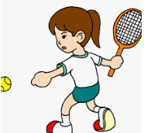
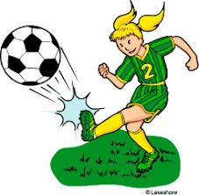

football tennis hockey
At the seaside I will go on the



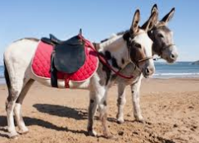

donkeys slide games beach

In the sea I saw

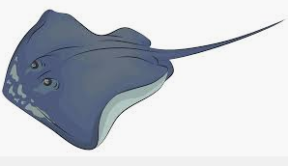
fish a stingray
Can you re-write the sentences using commas to separate items in the list?
Andy thought the sprinkles and the chocolate sauce and the ice cream looked delicious.
__________________________________________________________________________________
Harley and Mila and Lucas went swimming in the shimmering sea.
__________________________________________________________________________________
Tyler’s pack up box was filled with a sandwich and crisps and fruit.
__________________________________________________________________________________
In the deep sea we saw sharks and dolphins and stingrays.
__________________________________________________________________________________
Yesterday on the sandy beach I played with my bucket and spade and ball.
__________________________________________________________________________________
My favourite sports are hockey and football and tennis and netball.
__________________________________________________________________________________

In the woods I saw squirrels and rabbits and foxes running around.
__________________________________________________________________________________

My favourite sports are football and tennis but my brother likes hockey and basketball and netball.
__________________________________________________________________________________

I took my sun hat and spade and bucket to the beach but I forgot my rubber ring.
__________________________________________________________________________________

I felt upset because my friends were being mean and unkind and silly.
__________________________________________________________________________________

Can you write two of your own sentences using commas in a list? Can you challenge yourself and use a conjunction (and but so because) in your sentence as well?
__________________________________________________________________________________
__________________________________________________________________________________

