YEAR 2 HOME LEARNING
Week commencing 30th March
MATHS
Please click on the link below and follow these lessons. There is one for each day with a video explaining the mathematical concept. Please complete the activities on a piece of paper or print off the sheet. If possible, send a photo of your home learning via the learning email. We would love to see all the hard work you are doing.
https://whiterosemaths.com/homelearning/year-2/
For additional arithmetic and times tables practise please use these websites:
Maths Factor – All ages - https://www.themathsfactor.com/
Topmarks - https://www.topmarks.co.uk/maths-games/5-7-years/times-tables
Remember in year 2 we need to learn our 2, 5 and 10 times tables off by heart.
SPELLINGS
The spellings to learn for this week are: the ‘e’ sound at the end of a word spelt ‘ey’

donkey
monkey
key
chimney
valley
trolley
turkey
hockey
journey
parsley

Please get someone to test you at the end of the week. Keep a record of your scores!
READING
Please ensure you are reading every day or at least 3 times a week.
If you enjoy David Walliams books, he is uploading free audio books every day at 11am. Please follow this link https://www.worldofdavidwalliams.com/elevenses/
These websites also have books to download / listen to.
Audible Books – Free audio books for all ages - https://stories.audible.com/start-listen
World Book – Free eBooks and audio books for all ages - https://worldbook.kitaboo.com/reader/worldbook/

ENGLISH
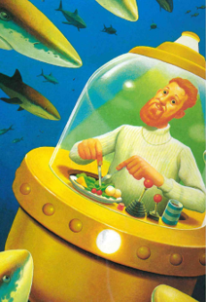
We have been reading the story ‘Dougal the Deep Sea Diver’ in class. Here are some illustrations of Dougal.
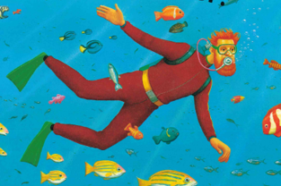


Write a character description for him thinking about what he looks like, what he enjoys doing and how he behaves. Remember to:
-use capital letters and full stops to start sentences
-include different conjunctions e.g. and so but because when
-include expanded noun phrases e.g. ginger hair, kind face

Please take a photo and email it to the learning email. We would love to see your finished fact file.

TOPIC – Explorers
At the beginning of the topic, the children wanted to find out who was the first explorer to climb Mount Everest. Use ‘Kiddle’ the child friendly search engine to answer these questions:
Who was the first person to climb Mount Everest?
How long did it take? What was the journey like?
Can you create your own space art crafts linked to our work on space and Neil Armstrong?
Here is a useful link with some fun art and craft ideas for you to try:
https://artsycraftsymom.com/outer-space-crafts-for-kids/

PHYSICAL ACTIVITIES
Remember to look after both your physical and mental health. They are so important. These websites will help you keep active.
- Body Coach – Jo Wick live P.E. lesson at 9 am every day – (All ages) https://www.youtube.com/watch?v=K6r99N3kXME
- Cosmic Yoga – https://www.youtube.com/user/CosmicKidsYoga
- Stay Active – Premier Education Free activities to stay active at home - https://www.premier-education.com/stay-active/

Finally, don’t forget Purple mash Purple Mash - https://www.purplemash.com/sch/beechwood-ls14

We hope you can complete as many of these activities throughout the week and really look forward to seeing all your hard work!!

Please look after yourselves and your family and we hope to see you all again very soon.

Miss Westfield
Miss De Biasio

