
Class 12 Newsletter
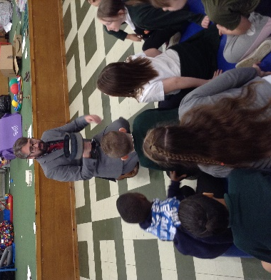
Class 12 have had a great first half-term of Year 5. Miss Warren and the rest of the team at Beechwood have been delighted by the hard work and positive attitudes the students have shown. Every child should be incredibly proud of their progress so far! We are now one week into the second autumn half-term, so we thought it was a good time to send out a newsletter.
What we are studying:
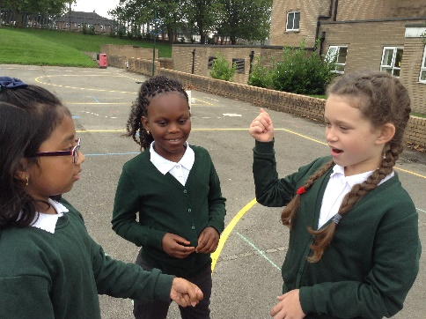
This half-term, Year 5 are continuing with the topic of ‘The Victorians’. In this topic so far, we have collected lots of information from doing research and enquiry, reading novels set in the Victorian era and a visit from Matthew Bellwood. In art, we have studied a Victorian artist: William Morris. Based on his work, we have designed our own colourful tiles. Miss Warren has been incredibly impressed by the artistic ability that Class 12 have shown in this!
We have done lots of work based on the Charles Dickins novel ‘Oliver Twist’, including writing a play script and a piece of persuasive writing. We are continuing to look at this book this half term and are working towards story writing. In guided reading, we have read a variety of Victorian themed texts and are now continuing the Victorian theme by reading the novel ‘Street Child’ and looking at Victorian poetry.
Acting out a scene from Oliver Twist
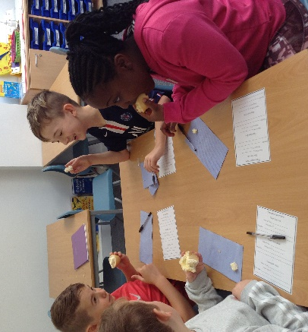
In maths, Class 12 began the year by looking at place value and have now moved onto the four operations: addition, subtraction, multiplication and division. Our next step will be using our multiplication and division knowledge to solve problems and reason our answers. Miss Warren has been very impressed with how much Class 12 have remembered from Year 4, especially showing clear workings out.

Important information for this half-term:
- Hopefully, most students have now tried logging onto ‘Seesaw’, which we are beginning to use for setting tasks. Each pupil has been given a log-in but if you are having any issues, please let Miss Warren know and she can help.
- Class 12’s PE days have changed for this half term. PE will now be on Tuesdays and Thursdays so children will need to wear their PE kits on these days, unless told otherwise. As we move into colder weather it is important that children wear cold weather PE kit such as tracksuit bottoms and a jumper to keep warm through the day and at playtimes and lunchtimes.
- Please continue to follow the current guidance from Beechwood, regarding Covid-19 policies. If you have any questions, please see the risk assessment on the school website or contact the school office.
- Keep an eye on the Class 12 page of the school website for more regular updates this half-tem, including our weekly certificate winners!
Class 12, keep up the amazing work!
From Miss Warren and the Year 5 Team

