YEAR 3 HOME LEARNING
Week commencing 22nd June

Thank you to everyone who has sent in pictures and their home learning to: learning@beechwoodprimaryschool.co.uk we love seeing what you have been getting up to!
We already have some brilliant jigsaw pieces back for our ‘Apart but Together challenge’. Keep sending them in. We are looking forward to seeing who enters our Summer Competition too.

EXCITING NEWS!
Even though we are not all at school, some of Year 6 have been busy thinking about how we can still do Spirit Alive this year. Next week’s work pack will include information about how you can get involved with the fun while you are at home.

MATHS
Please click on the link below and follow the weekly lessons.
https://whiterosemaths.com/homelearning/year-3/
The worksheets to go alongside these lessons are on our website.
https://www.beechwoodprimaryschool.co.uk/whiterose-maths-worksheets/
These can also be used alongside the daily BBC Bitesize maths lessons: https://www.bbc.co.uk/bitesize/tags/zmyxxyc/year-3-and-p4-lessons/1

ARITHMETIC
Don’t forget to keep practising multiplication and division tables and number bonds.
Oxford Owls -https://home.oxfordowl.co.uk/kids-activities/fun-maths-games-and-activities/
Top Marks - https://www.topmarks.co.uk/maths-games/7-11-years/ordering-and-sequencing-numbers
Numbots – Years 2-6 - https://play.numbots.com/#/account/school-login/3913 - Use your TT Rock Stars username and password.
Maths Factor – All ages - https://www.themathsfactor.com/

SPELLINGS
Keep practising the Year 3 high frequency spellings from your word pack. How well are you doing?
Can you spell: words with a double consonant ending in le?

bubble puddle apple dazzle kettle
wobble paddle middle little shuffle

How many other words can you find that have a double letter in them?

READING
https://www.worldbookday.com/storytime-online/
The World Book Day website are offering ‘Storytime Online’. Watch a wonderful range of famous authors and stars reading children’s books and short stories. Remember to keep reading at home

WRITING
Imagine you are exploring deep under the sea. What would it be like? What adventures would you have?
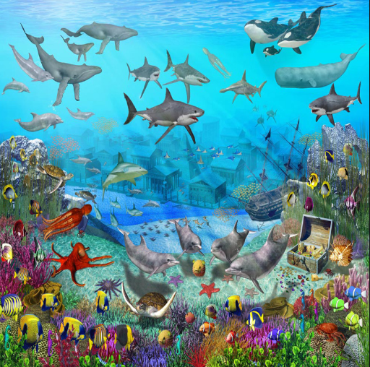

First of all, think about what you would be able to see, hear and feel. How can you describe it?
You need to remember to use capital letters and full stops correctly and to think about the conjunctions you want to use.

In your setting description, make sure you include expanded noun phrases, adverbs to describe some of the verbs and a range of conjunctions.
Miss Smith has made some videos on the school website to help you to remember how to use them. Go to Children ›› Grammar Demonstration Videos.
Try and use different sentences starters to make your writing more interesting.
You could start like this: Excitedly, I leapt off the side of the tiny sailing boat and dived quickly down to the bottom of the deep, mysterious sea. All around me…..

SCIENCE
Our Science topic this half term is Forces! Have a look on the class page for the home learning grid that Miss Smith has made for you. Can you do some research into magnets and friction? Can you do an investigation into forces at home? There is a great activity hands-on where you can make a raison dance!
We would love to see what you get up to and what you manage to find out! Send us photos or the work you have done to: learning@beechwoodprimaryschool.co.uk

PE
School Games Organisers are supporting the national effort to ensure young people and their families have access to fun ways of staying active. Over the next 26 working days the CSW SGO’s will be bringing you challenges linked to the School Games.
http://www.thinkactive.org/wethinkactive/kids-active-learning/a-z-challenge/

Well done to everyone for your hard work at home.
Take care and we hope to see you all soon.
Miss Smith and Miss Callaby

