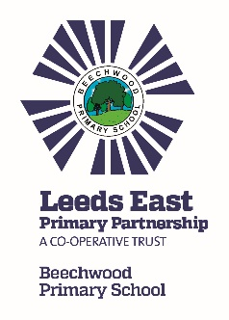

Trust News Update

Our Trust schools (Beechwood, Cross Gates, Grange Farm, Seacroft Grange & White Laith) continue to work together to provide even better outcomes and opportunities for children, their families and the wider community.

What activities has the Trust been working on?
The Trust has developed a number of activities which will benefit your children, including:

- Whole Trust Executive Functioning Training with Victoria Bagnall from Connections in Mind.

- SENDCOs have worked together to embed the newly designed Neurodiversity Policy in our schools.

- Termly joint year group and subject leader meetings provided opportunities for staff to work together and share ideas.

- ECTs have had an opportunity to meet their colleagues and visit each other’s schools.

- Peer to peer reviews have had a positive impact and provided potential for learning and sharing ideas.

- There are opportunities for all staff to work together depending on need.

- Business Managers continue to support each other with a focus on getting best value.

- Trustees have had an opportunity to visit schools to get a better understanding of all the schools in the Trust.

- Inter-school sporting competitions in various sports provided more opportunities for children to engage in physical activities and team games.

- All teaching staff were given the opportunity to visit each other’s schools to observe metacognition strategies in action. The retrieval and metacognition working group are developing exemplification videos providing clear examples of effective practice that can be used in their own classrooms.

- We are delighted that Fieldhead Carr Primary School has joined us as associate member, and we look forward to working together.

For further information about the Trust, please look at our website http://www.leedseastprimarypartnership.co.uk. We will continue to work on further activities to benefit your children.

We wish you all a lovely summer!

