Reception Newsletter
We are very excited to see our new Reception children starting Beechwood Primary School this week.
We are really proud of how the children have come in and listened well to all their new routines and also had lots of fun! We are so happy you have chosen Beechwood for your child.

Our topic
This half term’s topic is ‘I wonder what makes me special?’ We will be learning all about ourselves and our bodies. We will look at who is in our families and where we live. We will focus on how we are all unique and all our different talents, likes, dislikes and more.

Our 5 key texts for this half term are:
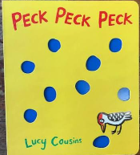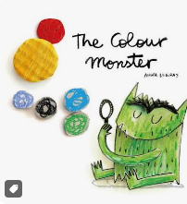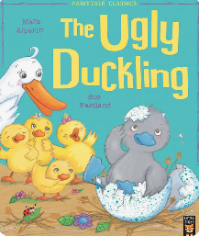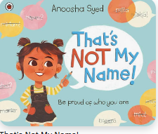
Our focus poem for the half term is Hands by Julia Donaldson.
Our focus nursery rhymes for the half term are: Two little Dickie Birds, Heads, shoulders, knees and toes and I’ve got a body.

Home School diaries
All children will receive a new home school diary on Friday 11th September. They are filled with lots of
information to help support your child’s learning at home. You can find a copy of our home learning mats in here too. Please help your child to look after these and make sure they are in school every day. We would love to see any reading or extra learning your child has done at home recorded each week. A
separate letter will be sent out about reading book.

P.E
PE will begin on the w/c 14th September.
Class 1 PE day- Monday
Class 2 PE day- Tuesday
Please send your child into school in their PE kit on these days. On PE days we ask for earrings to be removed.

Water bottles
Please send your child to school with a named water bottle every day. Their bottles must only have water in them to drink during the day.

Reception baseline assessment
Your child will be participating in the reception baseline assessment (RBA) within the first 6 weeks of starting reception. The purpose of the assessment is to provide the starting point for a progress measure that will help parents understand how well schools support their pupils to progress between reception and year 6.

Outdoor learning
In reception we will be outside everyday no matter the weather. Please send your child to school with a waterproof coat for wet and rainy days. If you haven’t already please send it in with a named pair of wellies, these can be kept at school so they are always ready to be outside. Thank you to all those parents that have also sent in waterproofs that we can keep in school for your child.

Names
Please remember to put names in all jumpers, cardigans, coats, lunch boxes and water bottles to enable us to keep track of all belongings.

Dates for your Diary
Thursday 17th September – Class 1 Parent and Children Lunch day 11.30am
Friday 18th September – Class 2 Parent and Children Lunch day 11.30am
Wednesday 14th October – Phonics Stay and Play 9.00-9.45am
Tuesday 20th October – Black History Month Assembly 2.30pm
Wednesday 21st October – Parents Evening

We cannot wait to have an amazing first half term in Reception!

Thank you,
Mrs Matharoo, Mrs Williamson, Miss Martin, Miss Noreen and Miss Appleyard.

