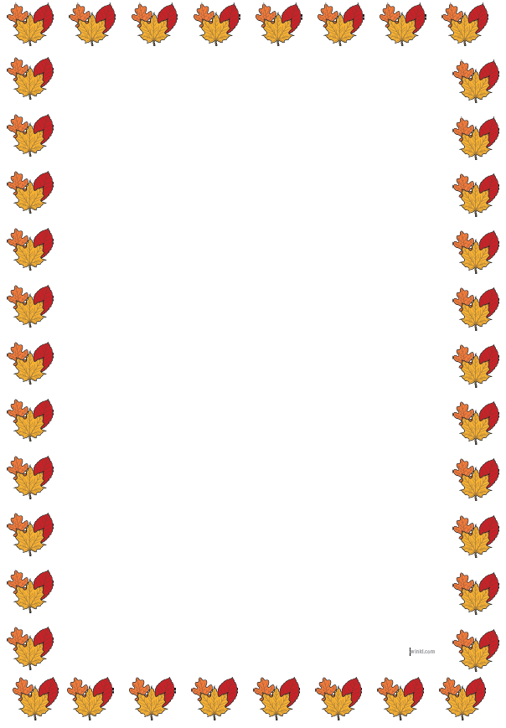
Year 2 Newsletter
Welcome back! We hope you have all enjoyed the summer holidays and are excited to be back in school to do lots of learning.
Autumn term
This term we will be learning all about South Africa. We will be using maps to find out where it is and learn about the continents and oceans around the world. We will also be finding out about a very important person called Nelson Mandela. We have planned an exciting visit to the Yorkshire Wildlife Park on Tuesday 10th November and we will give out more details later this half term in a separate letter.

Home-school diaries
All children will receive a new home school diary. They are filled with lots of information to help support your child’s learning at home. Please help your child to look after these and make sure they are in school every Friday. We’d love to see any reading, homework or extra learning your child has done at home recorded each week.

P.E.
Class 5 P.E. days are days and days and Class 6 P.E. days are Wednesdays and Thursdays every week this half term. On these days, please send your child to school wearing a suitable P.E. kit. Children should not wear crop tops, football kit or footwear that is not suitable for sporting activities. On P.E. days we ask that earrings are removed if possible.

Water bottles
Please send your child to school with a water bottle every day. Their bottles must only have water in them to drink during the day.

Reading books
Your child will have their reading books changed once a week. Please make sure they bring their books to school to be changed on Fridays. Please try and read with your child every day or at least three times a week.

Homework
Spellings will be sent home every Friday to learn at home for a test in school the following Friday. Please help your child to practise these everyday using the spelling sheet and online using ‘Spelling Shed’. Maths homework will be sent home on Fridays but this will start next half term.
Many thanks,
Miss Warren and Miss Mulvihill

